**國立中山大學雙語教育資源中心 EMI教師培訓計畫**

**研習證明及培訓證書下載操作步驟**

**Instructions for downloading Attendance Records and Certificates of Completion**

**from the EMI PD Program of the Resource Center for Bilingual Education, NSYSU**

Website: <https://emi-tdc.nsysu.edu.tw/index.aspx>

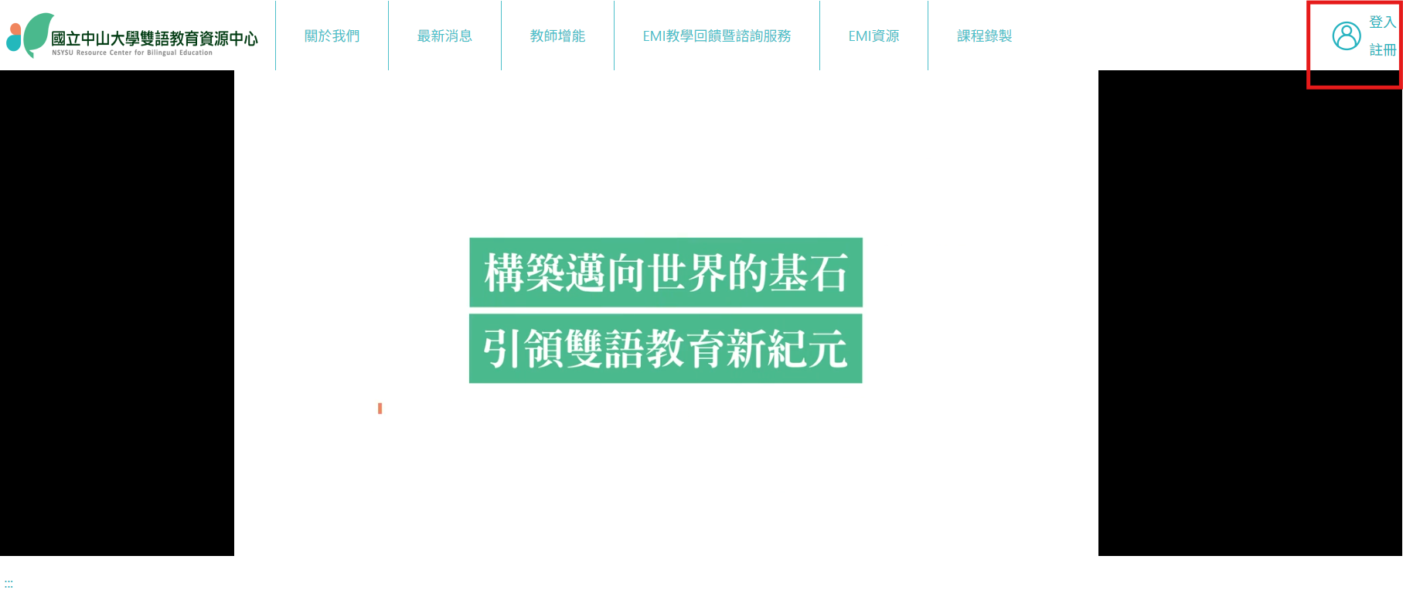

NSYSU Faculty: Login with SSO

中山大學教師：請使用SSO登入

Non-NSYSU Faculty: Register with ID/ARC number

外校教師：請以身份證/居留證號碼註冊

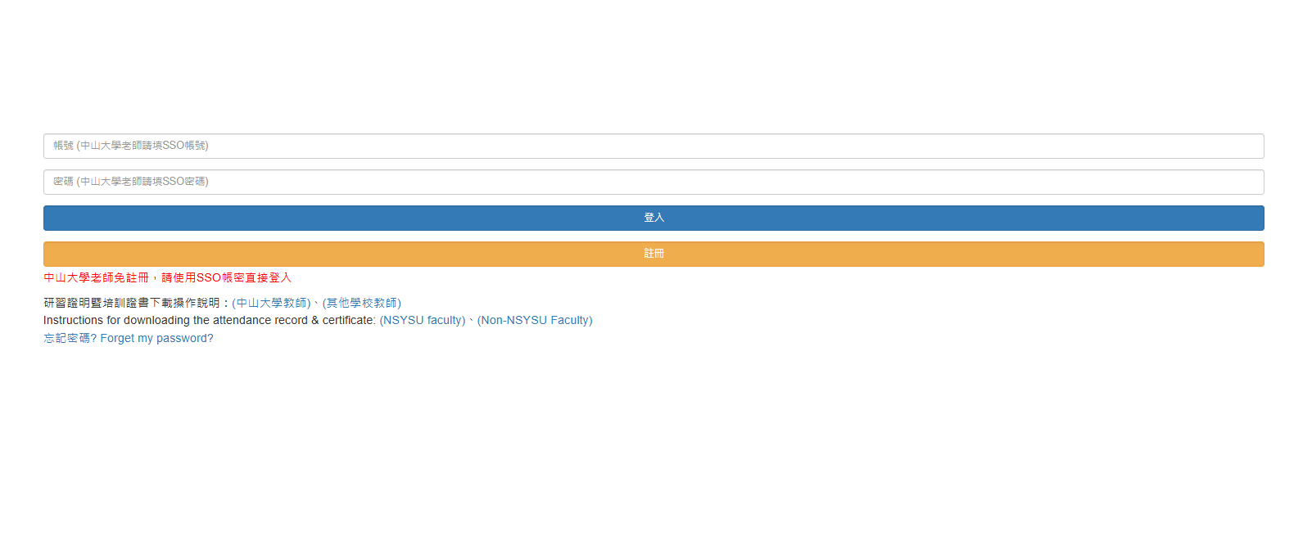

閱讀隱私權保護政策後，點選【同意收到本網站相關資訊，並繼續使用。】

Read the Privacy Policy and click [Agree to the terms of this website.]

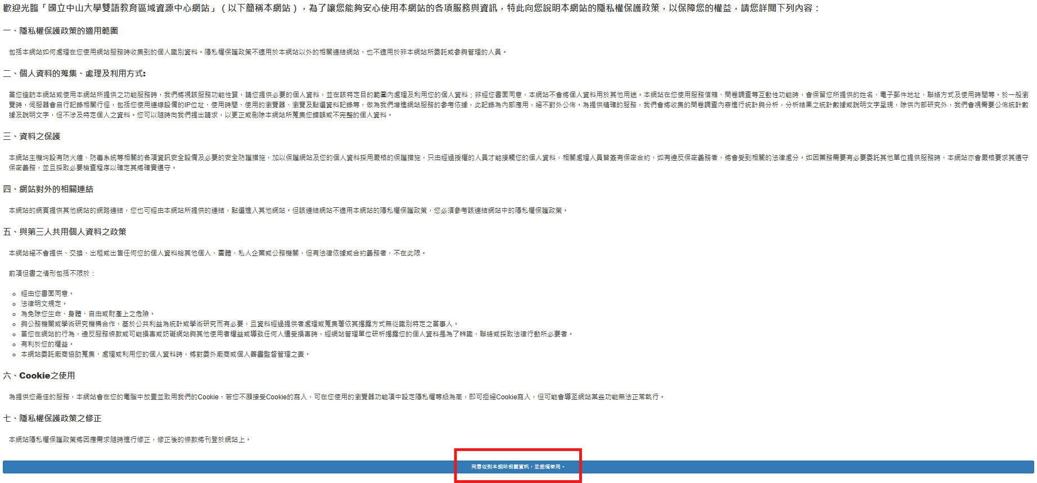

從【培訓課程】中選擇【舊制】或【新制】  
Under [Professional Development Courses] (培訓課程), choose [Previous Program] (舊制) or [Current Program] (新制).

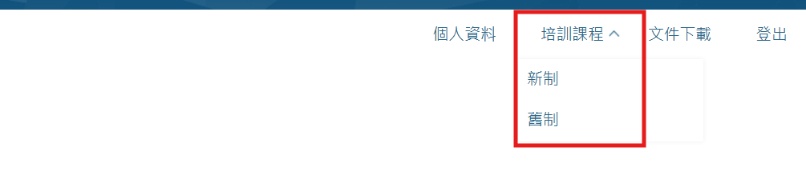

**【舊制】[Previous Program]**

選擇欲下載檔案後按【列印】，另開視窗(允許彈出視窗)，PDF檔供下載或列印   
(可列印證書僅出現已完成培訓課程的部份，未出現代表課程未完成；  
 研習證明記錄參與的所有培訓課程。)

Choose the file and click the Print button 【列印】. A new tab will pop up (Allow pop-up windows) with the Certificate of Completion in PDF for you to download or print. The drop-down menu displays the levels you have completed.

If you have not completed any levels, no “Certificate of Completion” will appear for you to download or print.

You may also print an Attendance Record, which records all events you have participated in.

*舊制執行至2025.01.31，若未取得研習證明請修習新制

*The Previous Program is in effect until January 31, 2025. For teachers who have yet to receive Certificates of Completion, please participate in the Current Program.

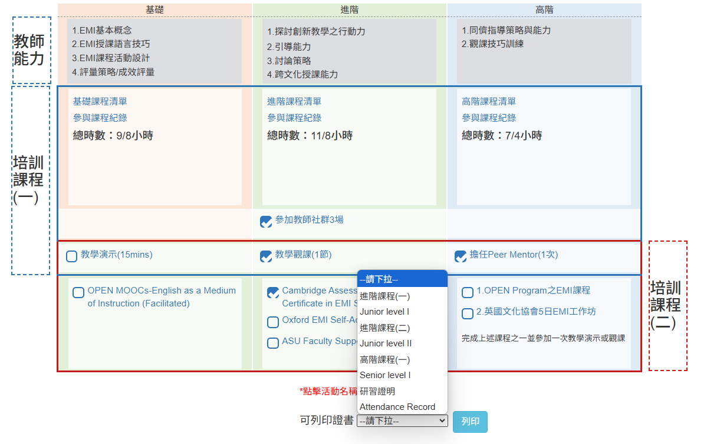

**【新制】[Current Program]**

選擇欲下載檔案後按【列印】，另開視窗(允許彈出視窗)，PDF檔供下載或列印   
(可列印證書僅出現已完成培訓課程的部份，未出現代表課程未完成；  
 研習證明記錄參與的所有培訓課程。)

Choose the file and click the Print button 【列印】. A new tab will pop up (Allow pop-up windows) with the Certificate of Completion in PDF for you to download or print. The drop-down menu displays the levels you have completed.

If you have not completed any levels, no “Certificate of Completion” will appear for you to download or print.

You may also print an Attendance Record, which records all events you have participated in.

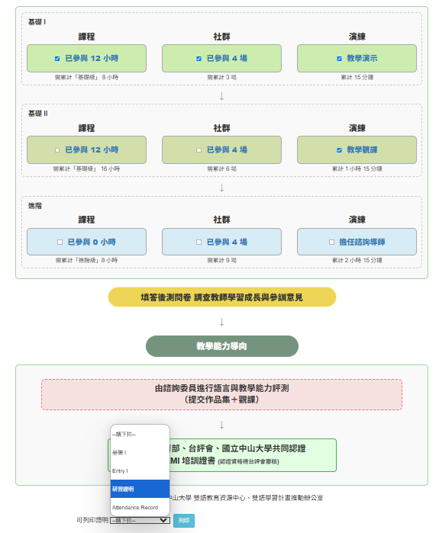

**培訓課程**

● 培訓課程可分為資源中心舉辦之實體或線上同步工作坊，及中心認列之國際機構線上課程。

● 國際機構之線上課程以該開授課程機構所授予之完課證明進行採計。

**教學演示/觀課**

● 由資源中心邀請EMI專家 (Expert) 與顧問教師 (Mentor)，提供EMI教學回饋與諮詢服務。

● 教師經由資源中心網頁公告之線上表單申請教學演示/觀課，教學演示採錄影進行，教學觀課原則上實體進行。完成後由EMI專家/顧問教師回傳教學演示/觀課紀錄，經資源中心確認後登錄。

**教師社群**

● 加入EMI教師培訓計畫後，每階段需參與三次教師社群活動，可跨學期累計次數。

● 參與教師社群活動次數經計入單一階級培訓認證後，不得累計至下一階級培訓課程。

**Professional Development Courses:**

● Professional Development Courses consist of onsite and synchronized online workshops held by the Resource Center, and online courses offered by international institutions and recognized by the Resource Center.

● Online courses completed with certificates from recognized institutions will be accepted as credit towards the EMI Professional Development Program.

**Microteaching/Classroom Observations:**

● Experts and scholars invited by the Resource Center serve as EMI Experts of Mentors and offer Teaching Feedback and Consultation Services.

● Teachers can apply for Microteaching/Classroom observation services through a registration form on the Resource Center's website. Microteaching is conducted by video recording, and Classroom Observations are, in principle, conducted on-site. The EMI Expert/ Mentor will provide feedback on the Microteaching/Classroom Observation session, and the session will be reviewed and accounted by the Resource Center.

**Teacher Community:**

● In the EMI Professional Development Program, attendance in three Teacher Community gatherings is required for each level. Attendance can accumulate across semesters.

● The record of each Teaching Community can only be accounted for once, and can neither be carried over nor be reused in the next level of training.